Week 5 Network Connection Stream
The application utilizes Firebase Firestore as its primary cloud database. The network architecture relies on persistent, real-time snapshot listeners that stream data changes via Kotlin Coroutines and StateFlows, rather than relying on traditional one-off HTTP REST calls

1. The Core Network Engine
File: AppRepository.kt
This is the most critical file for network communication. It abstracts the cloud backend away from the rest of the application.
- Initialization: It initializes the FirebaseFirestore network client.
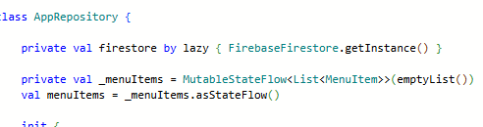
- Real-time Streaming: It opens persistent network streams using .addSnapshotListener(). Whenever a document is added, modified, or deleted in the cloud the network stream automatically pushes the delta to the app.
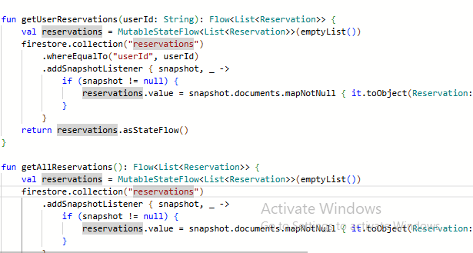
- Downstream Bridging: It converts these proprietary Firebase streams into Kotlin MutableStateFlow, providing a clean, reactive data pipeline to the ViewModel.
- CRUD Operations: It handles uploading data suspending the coroutine until the network request successfully completes.
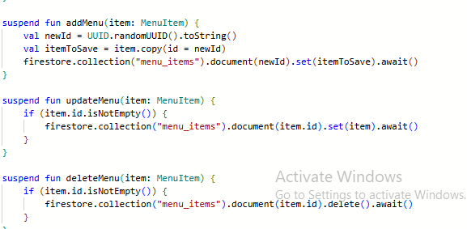

2. The State Manager
File: MainViewModel.kt
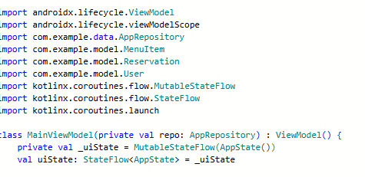
This file acts as the bridge between the network streams and the user interface.

- Consumption: It listens to the StateFlow streams exposed by the AppRepository.
- Authentication & Lifecycle Binding: It triggers network actions (like login and register) and observes user-specific reservation streams based on the authenticated user ID.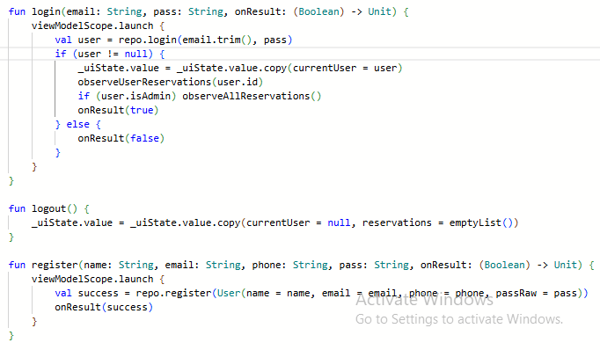
- UI State Sync: When new data arrives through the network socket, this file updates the _uiState, immediately forcing the Jetpack Compose UI to recompose and display the latest cloud data.

3. Network Configuration & Dependencies
- app/google-services.json
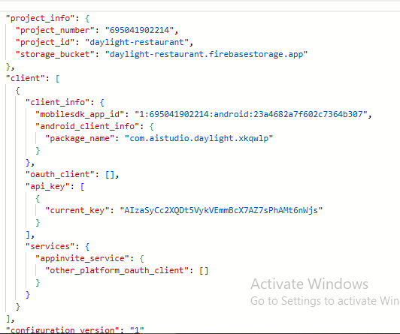
- app/build.gradle.kts & gradle/libs.versions.toml
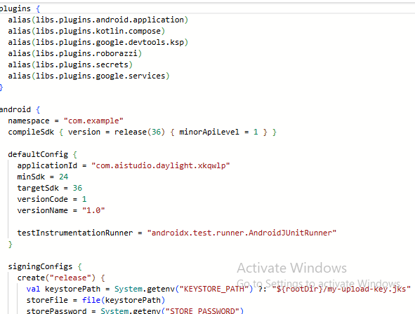
- Configuration: google-services.json contains the secure client IDs, API keys, and project numbers required to authenticate the network connection with Google's Firebase servers.
- Dependencies: The Gradle files pull in the actual network libraries required to transmit data, specifically firebase-firestore and firebase-auth.
4. System Permissions
File: app/src/main/AndroidManifest.xml
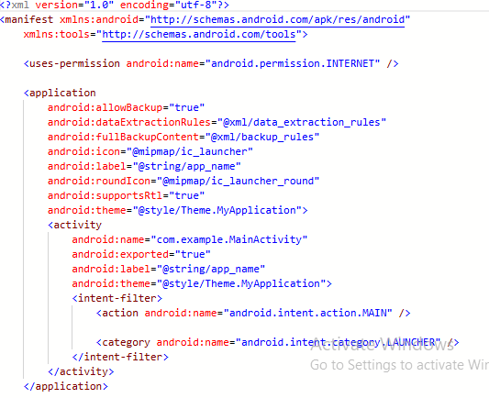
- Authorization: Contains the explicit declaration <uses-permission android:name="android.permission.INTERNET" />. This is required by the Android OS to grant the application permission to open network sockets and stream data.

5. Data Serialization Models
Files: app/src/main/java/com/example/model/MenuItem.kt, User.kt, Reservation.kt
- Data Mapping: They represent the exact payload structure transmitted over the network. They use id: String to seamlessly map local objects to unique Firestore document IDs during network serialization and deserialization.
Need for networking
The app needs networking to sync menus, reservations, and user profiles in real-time with the Firebase database.

